Student: IEREMIAȘ Viorel

Group: 244

Assignment no.: 2

Assignment topic: EJB

**Requirement**

*“Tema EjbJpa presupune realizarea unei aplicatii relevante care sa foloseasca EJB, JPA, Servleturi (si eventual JSP). Aplicatia va trebui să contină un server ce să gestioneze minimum două tabele în DB care să aibă relaţii între ele. Mai trebuie să conţină doi clienţi, unul care să apeleze serverul prin JNDI, celălalt să folosească injectarea EJB. Aplicatia trebuie să fie instalabilă atat pe AS WindFly (JBoss) cat si pe AS GlassFish. Arhiva cu aplicatia trebuie uploadată prin portalului AMS, conform cerintelor de la: prezentare lucrari. Continutul aplicatiei va fi discutat in cadrul seminarului inainte de a fi elaborat.”*

**Proposed solution**

A flight management and tracking system. The main functionality consists in displaying information about flights. The filtering capacity allows a refined search, that meets the criteria relevant for the user: departure and arrival location, as well as dynamic ranges of dates for both the departure date and the arrival date.

The filter options are dynamically set, i.e. after the user selects the desired destination country, the selection tool for the destination city in the filter area is automatically filled with the available destination cities in the country. In the context of hundreds of possible destinations cities, displaying the relevant ones significantly improves the user experiences. Moreover, it prevents data inconsistencies that might occur when one user selects a city that is not part of the previously selected country. It also improves the ability of the system to integrate the constant changes that appear in flight routes.

**Architecture**

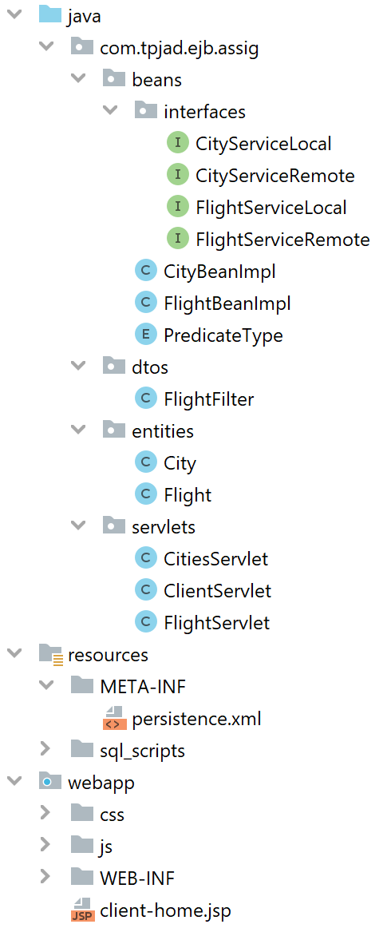

**Gradle** is used as buildsystem for its flexibilty in configuring custom build pipelines. The **war** deployment is built from the **Assignment2** module. The 2 clients (Glassfish and Wildfly) are built from the **Assignment2ClientGF**,respectively **Assignment2ClientWF** project.

**Installation**

The build script at the root level of the projects coordinates the execution of the separate builds and collects the artifacts at the root-level **build/libs** directory.